1. The Problem
- Retailers currently manually check stock and report via phone, SMS, or WhatsApp.
- Nestlé management only receives sales data 24–48 hours later.
- Leads to stockouts, overstocking, and inefficiency.
- Minor delays in information cause Bullwhip Effect: small delays → big supply chain problems.
- Manual processes are slow, error-prone, and non-transparent.

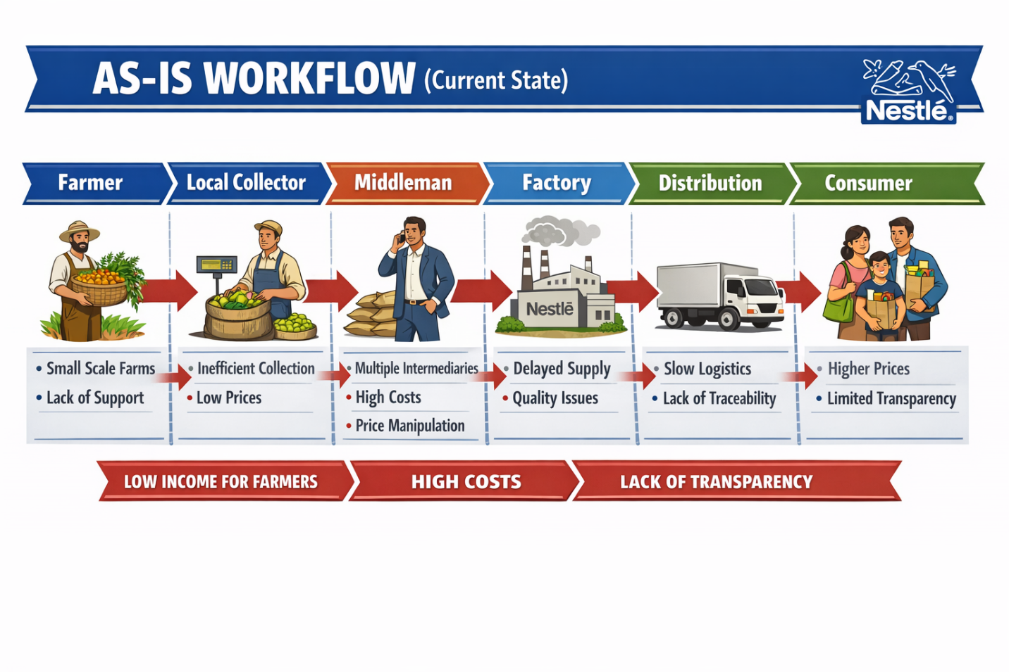
Figure 1 Current Workflow

2. The Solution
- Name: Nestlé SmartFlow
- Type: Web-based Application (cloud-enabled, interactive)
- Purpose: Digitize the last-mile inventory system.
- Goal: Close the “information gap” between retailers, distributors, and Nestlé management.
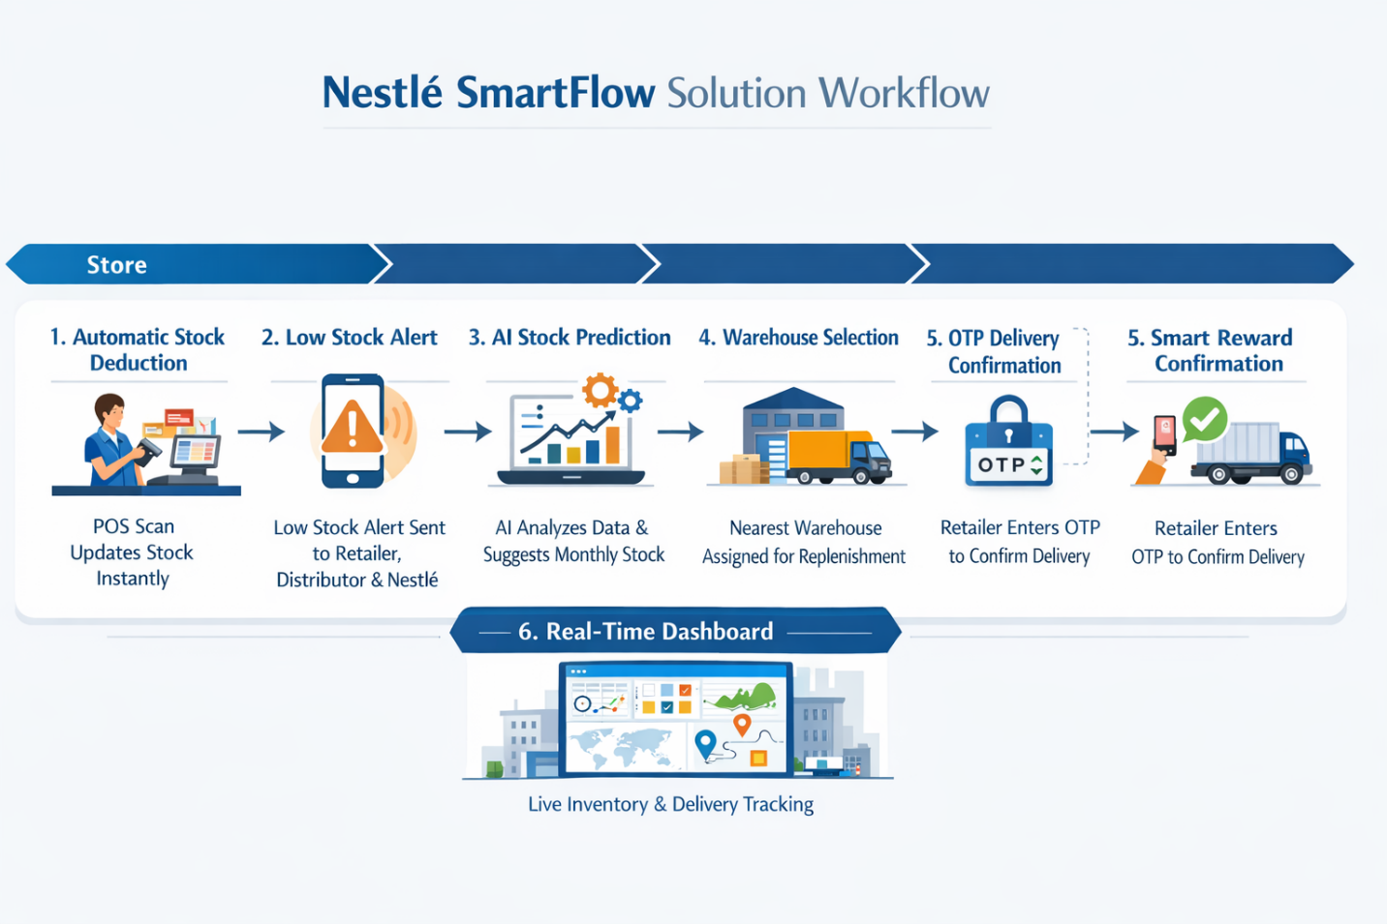
Figure 2 solution we have come up with

3. How It Works (Step-by-Step)
Step 1: Product Sale
- Cashier scans the product at the POS.
- Inventory is automatically reduced by the quantity purchased.
Step 2: Threshold Check
- System checks if stock < safety threshold.
- If low, it triggers a low-stock alert to retailer, distributor, and Nestlé management.
Step 3: AI Stock Recommendation
- AI analyzes past sales and suggests monthly stock to prevent over/under-ordering.
Step 4: Distributor Delivery
- Distributor identifies the nearest warehouse using retailer location.
- Prepares delivery for the retailer.
Step 5: OTP Confirmation
- Nestlé management sends an OTP to the retailer.
- Retailer enters OTP on distributor’s device to confirm delivery.
- System notifies Nestlé that delivery was successful.
Step 6: Real-Time Dashboard
- Shows live inventory, sales trends, and delivery status for all stakeholders.

4. Core Features
Here are the core features, why they matter, and what problems they solve:
  - Real-Time Inventory Tracking (Main Core Feature)
Problem solved:
Nestlé and distributors don’t know the actual stock levels in shops until 24–48 hours later, which causes stockouts and poor supply decisions.
How it works:
Every time a cashier scans a Nestlé product at the POS, the system automatically records the sale and updates the shop’s inventory in the cloud instantly.
Benefit:
Nestlé managers, distributors, and retailers can see the real stock level of every shop in real time, allowing faster restocking and preventing empty shelves.

2. Core features: Statistical Stock Recommendation
  - Problem solved: Over/under-ordering and waste due to inaccurate stock estimates.
  - How it works: The system calculates the average past monthly sales for each product and adds a safety stock buffer based on variability in daily sales and delivery lead time. This gives a recommended stock level for upcoming month
  - Benefit: Retailers and distributors get practical, data-driven stock suggestions, reducing stockouts, overstocking, and waste.
- Low-Stock Alerts
  - Problem solved: Stockouts caused by delayed reporting.
  - How it works: Automatic alert to retailer, distributor, and Nestlé management when stock is low.
  - Benefit: Keeps shelves stocked, prevents lost sales.
- Online Reorder System
  - Problem solved: Manual, fragmented ordering via calls or WhatsApp.
  - How it works: Retailers place orders in-app directly to distributor.
  - Benefit: Faster replenishment, reduces delays.
- OTP Delivery Confirmation
  - Problem solved: Confirms that delivery was actually received, avoiding disputes.
  - How it works: Retailer enters OTP on distributor’s device, alerting Nestlé management.kiollk
  - Benefit: Ensures delivery accuracy and accountability.

- Core Feature: Warehouse-to-Shop Stock Allocation
  - Problem solved: Shops may run out of stock or get delayed deliveries if the warehouse isn’t optimally chosen.
  - How it works System chooses the best warehouse to supply each shop based on proximity, current stock, and shop demand.
  - Benefit: Ensures timely deliveries, reduces shipping costs, and keeps shops stocked efficiently.

5. Architecture
- Three-Tier Web Application:
  - Presentation Layer – Cashiers, distributors, and managers use a web app interface.
  - Application Layer – Business logic: stock updates, alerts, AI suggestions, OTP verification.
  - Data Layer – Cloud-based SQL database: single source of truth.
- Secure: Role-Based Access Control (RBAC).
- Scalable: Supports multiple stores, warehouses, and distributors.
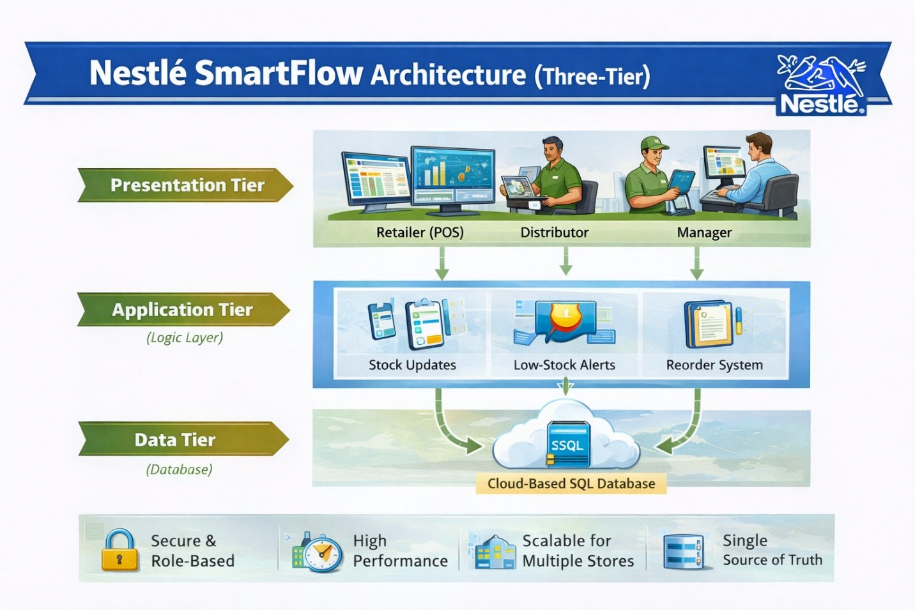
Figure 3 Three-tier architecture

6. Stakeholders & Access
Stakeholder | Role/Access
Cashiers/Retailers | Scan products, view store stock, approve OTPs, place orders.
Distributors | Receive low-stock alerts, manage deliveries, access nearest warehouse info.
Nestlé Managers | Monitor all stock, sales trends, warehouse status, delivery confirmations.
Development Team | Maintains system, updates AI, dashboards, and database.

7. Beneficiaries
- Nestlé: Real-time visibility, accurate forecasting, reduced inefficiency.
- Retailers: Accurate stock, faster restocking, reduced stockouts.
- Distributors: Optimized deliveries, reduced manual coordination.
- Consumers: Products are always available.

8. Why the System Is Practical
- Real-time updates eliminate 24–48h info lag.
- Reduces human error with automated stock deduction.
- Ensures delivery accountability with OTP verification.
- AI-driven stock suggestions minimize overstocking and understocking.
- Cloud-based and scalable for future upgrades (AI, IoT shelves).
- Practical for cashiers, retailers, distributors, and management alike.

